**Dr B R Ambedkar National Institute of Technology**

Grand Trunk Road, Barnala - Amritsar Bypass Road,

Jalandhar, Punjab 144011



**ITPC-221 OBJECT-ORIENTED PROGRAMMING CONCEPT LAB**

**B. TECH IT – II YEAR (3rd SEMESTER)**

Submitted by

Ajay Kumar Yadav

21124007

Submitted to

Dr Vanitha P S

Department of Information Technology

**QUESTION 9:** Program to show multiple inheritance.

***Multiple inheritance***

EX.NO.: 9

DATE :10/10/2022

AIM: Implementing multiple inheritance

#include <iostream>

using namespace std;

class base{

int a;

public:

void setdata (int x){

a=x;

}

int getdata(){

return a;}

};

class base2{

int a2;

public:

void setdata2(int x){

a2=x;

}

int getdata2(){

return a2;}

};

class derived : public base, public base2{

int c;

public:

int getdata3(){

c = getdata() + getdata2();

cout << c;

}

};

int main()

{ derived d ;

d.setdata(3);

d.setdata2(5);

d.getdata3();

return 0;

}

***OUTPUT :***

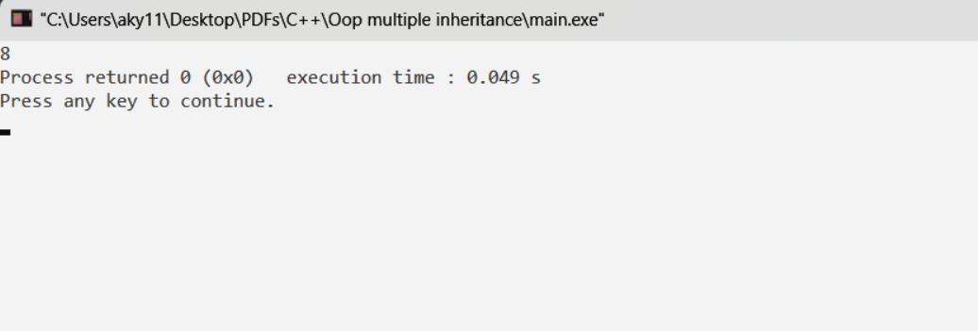

**RESULT**: code executed successfully.

**QUESTION 10 :** Program to show multilevel inheritance.

***Multilevel inheritance***

EX.NO.: 10

DATE :10/10/2022

AIM: implementing multiple inheritance CODE

#include <iostream>

using namespace std;

class student{

protected:

int roll;

public:

string name;

void setdata(int a, string n){

roll=a;

name=n;

}

void display(){

cout << "student have roll number "<< roll<< " and name " <<name <<endl;

}

};

class exam: public student{

protected:

int maths, physics;

public:

void setmarks( int m, int p){

maths=m;

physics=p;

}

int getm(){

return maths;

}

int getp(){

return physics;

}

};

class result: public exam{

public:

float getresult(){

cout << "Result of " <<name<< " is "<< ((float)getm()+(float)getp())/2<< "%" <<endl<<endl;

}

};

int main(){

result Ajay, unknown;

Ajay.setdata(2,"Ajay");

Ajay.display();

Ajay.setmarks(98,99);

Ajay.getresult();

unknown.setdata(36,"Unknown");

unknown.display();

unknown.setmarks(77,95);

unknown.getresult();

return 0;

}

***Output:***

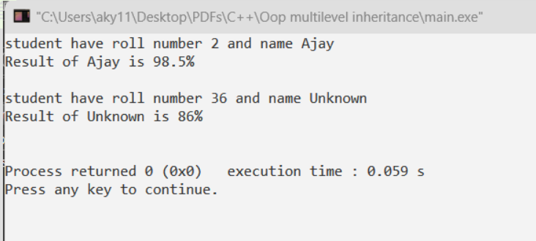

***RESULT***: code executed successfully.

**QUESTION 11:** Program to show hybrid inheritance.

***Hybrid inheritance***

EX.NO.: 11

DATE :10/10/2022

AIM: implementing Hybrid inheritance CODE

#include <iostream>

using namespace std;

class student{

protected:

int roll;

public:

string name;

void setdata(int a, string n){

roll=a;

name=n;

}

void display(){

cout << "student have roll number "<< roll<< " and name " <<name <<endl;

}

};

class exam: public student{

protected:

int maths, physics;

public:

void setmarks( int m, int p){

maths=m;

physics=p;

}

int getm(){

return maths;

}

int getp(){

return physics;

}

};

class reexam{

protected:

int extraSubject;

public:

void setExtraMarks(int m){

extraSubject = m;

}

void getExtraMarks(){

cout << "Score of reexam is : " << extraSubject <<endl;

}

};

class result: public exam,public reexam{

public:

float getresult(){

cout << "Result of " <<name<< " is "<< ((float)getm()+(float)getp())/2<< "%" <<endl<<endl;

}

};

int main(){

result Ajay, unknown;

Ajay.setdata(2,"Ajay");

Ajay.display();

Ajay.setmarks(98,99);

Ajay.getresult();

unknown.setdata(36,"Unknown");

unknown.display();

unknown.setmarks(77,95);

unknown.getresult();

unknown.setExtraMarks(20);

unknown.getExtraMarks();

return 0;

}

***Output:***

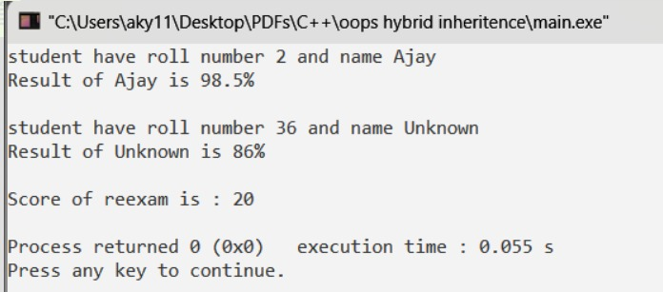

***RESULT***: code executed successfully.

**QUESTION 12:** Program to understand the Use of “this” Pointer.

***This pointer***

EX.NO.: 12

DATE :16/10/2022

AIM: implementing this pointer CODE

#include <iostream>

using namespace std;

class A

{

int a;

public:

A& setdata(int a )

{

this -> a =a;

return *this;

} void getdata()

{

cout <<a;

}

};

int main()

{

A ajay;

ajay.setdata(7).getdata();

return 0;

}

***Output:***

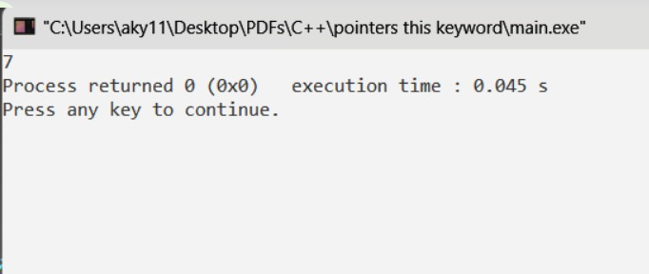

***Result:*** Code executed successfully

**QUESTION 13 :** Programs to Understand Storage Specifiers.

***Storage specifiers***

EX.NO.: 13

DATE :16/10/2022

AIM: Implementing program of storage specifiers.

#include <iostream>

using namespace std;

class shop{

int id;

float price;

public:

void setdata(int i, int p){

id=i;

price=p;

}void getdata(){

cout << "Id is "<<id<< " and price is "<<price<<endl;

}

};

int main()

{

int size = 3;

int p,q,i;

shop *ptr = new shop[size];

shop *ptrtem = ptr;

shop *ptritem = ptr;

for (i=0; i<size;i++){

cout<< "Enter id and price of item "<<endl;

cout<<i+1<< ". ";

cin>>p>>q;

ptr ->setdata(p,q);

ptr++;

} for (i=0;i<size;i++){

cout<<"item number: "<<i+1<<endl;

ptrtem ->getdata();

ptrtem++;

}

//to show addition in pointer

cout<<"item number: "<<i+1<<endl;

(ptrtem+2) ->getdata();

return 0;

}

***Output:***

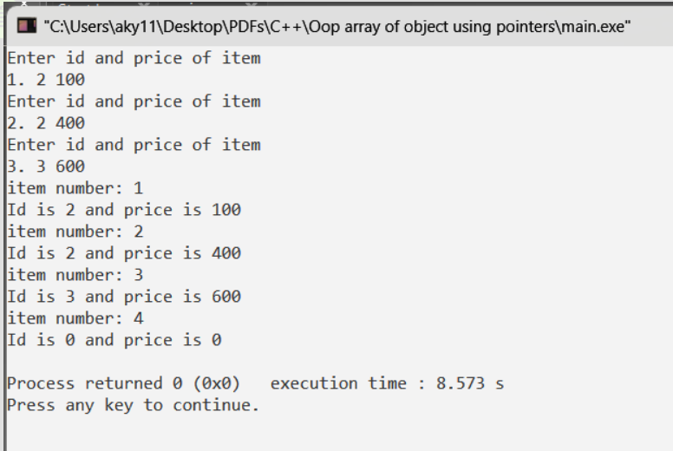

***RESULT***: code executed successfully.

**QUESTION 14 :** Programs to implement the concept of Pointer Arithmetic. a) Increment/Decrement of a Pointer b) Addition of integer to a pointer.

***Pointer arithmetic***

EX.NO.: 14

DATE :16/10/2022

AIM: implementing program of pointer arithmetic.

#include <iostream>

using namespace std;

class contained {

private:

int num;

public:

void shownum()

{

cout << "Hello from contained class\n";

cout << "num = " << num << endl;

}

int& getnum()

{

return num;

}

};

class container {

contained c;

public:

container()

{

cout << "Hello from container class\n";

c.getnum() = 70;

c.shownum();

}

};

int main()

{

container cont;

}

***Output:***

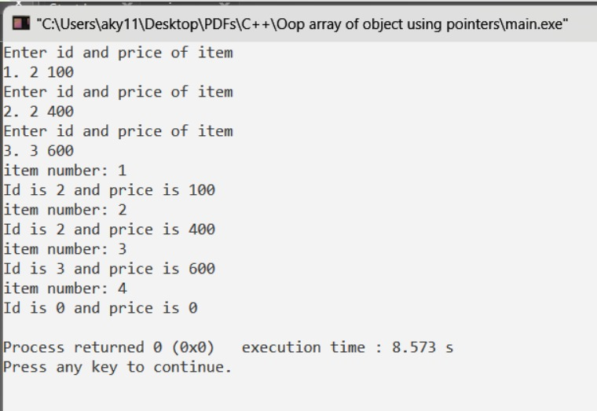

***RESULT***: code executed successfully.

**QUESTION 15 :** Program to show the concept of containership.

***Containership***

EX.NO.: 15

DATE :20/10/2022

AIM: implementing program ofcontainership.

#include <iostream>

using namespace std;

class contained {

private:

int num;

public:

void shownum()

{

cout << "Hello from contained class\n";

cout << "num = " << num << endl;

}

int& getnum()

{

return num;

}

};

class container {

contained c;

public:

container()

{

cout << "Hello from container class\n";

c.getnum() = 70;

c.shownum();

}

};

int main()

{

container cont;

}

***Output:***

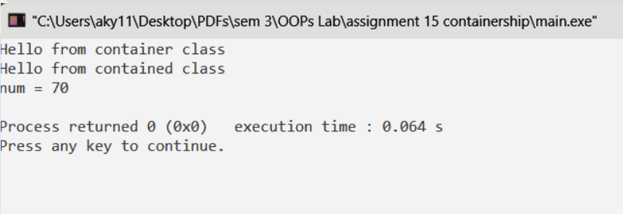

***RESULT***: code executed successfully.

**QUESTION 16 :** Program to show the concept of run time polymorphism using virtual function.

***Run time polymorphism using virtual function***

EX.NO.: 16

DATE :20/10/2022

AIM: implementingrun time polymorphism using virtual function.

#include <iostream>

using namespace std;

class base{

protected:

int a;

public:

void setdata(int x)

{

a=x;

} virtual void getdata()

{

cout<<a<<endl;

cout<<"this is display of base"<<endl;

}

};

class derive: public base{

int b;

public:

void setdata(int y) {

b=y;

}

void getdata() {

cout <<b<<endl;

cout<<a<<endl;

cout<<"this is display of derived"<<endl;

}

};

int main(){

base * bp;

base*q;

base bo;

derive deo;

q=&bo;

q ->setdata(8);

q ->getdata();

bp = &deo;

bp ->setdata(5);

bp ->getdata();

return 0;

}

***Output:***

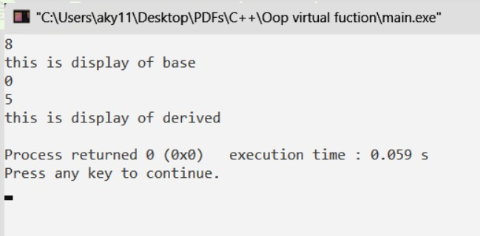

***RESULT***: code executed successfully.

**QUESTION 17:** Program to overload unary operator. a) decrement (--) operator b) logical not (!) operator.

***Operator overloading(unary)***

EX.NO.: 17

DATE :31/10/2022

AIM: implementing operator overloading.

#include <iostream>

using namespace std;

class A

{

int num;

bool flag;

public:

A(int a)

{

num = a;

flag = false;

}

void getnum()

{

cout << "Value of a is: "<< num <<endl;

}

bool getflag(){

return flag;

}

void operator -()

{

num--;

}

void operator !()

{

flag = !flag;

}

};

int main()

{

A a(5);

a.getnum();

-a;

a.getnum();

if(a.getflag()) cout << "Flag is true"<<endl;

!a;

if(a.getflag()) cout << "Flag is true"<<endl;

return 0;

}

***Output:***

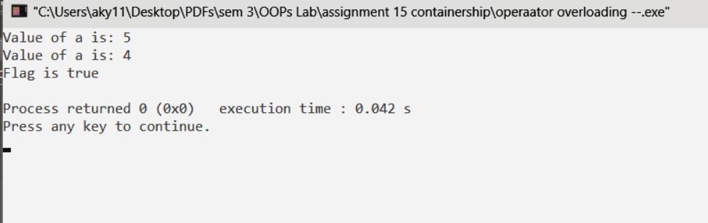

***Result***: Code executed successfully

**QUESTION 18:** Program to overload binary operator. a) % operator b) <= operator

***Operator overloading(Binary)***

EX.NO.: 18

DATE :31/10/2022

AIM: Implementing operator overloading.

#include <iostream>

using namespace std;

class A{

int num;

public:

A(int n){

num =n;

}

void getnum(){

cout<< "num is : "<<num<<endl;

}

A operator % (A &obj){

A res(0);

res.num = this->num % obj.num;

return res;

}

bool operator <= (A &obj){

bool res;

res = this->num <= obj.num;

return res;

}

} ;

int main(){

A a1(8),a2(3);

A a3 = a1%a2;

a3.getnum();

a1<=a2? cout<< "a2 is bigger than a1" <<endl: cout << "a1 is bigger than a2"<<endl;

return 0;

}

***Output:***

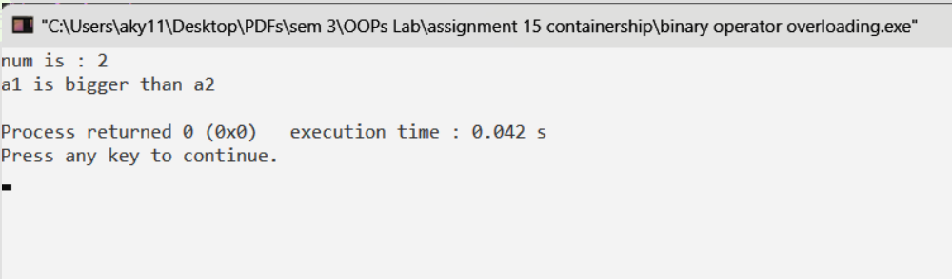

***Result***: Code executed successfully

**QUESTION 19:** Program to work with formatted and unformatted IO operations

***Formatted/Unformatted IO***

EX.NO.: 19

DATE :01/11/2022

AIM: Formatted and Unformatted IO

#include <iostream>

#include <windows.h>

using namespace std;

int main()

{

cout << "Demonstrating Formatted IO" <<endl;

int num1;

printf("Enter a integer number: ");

scanf("%d", &num1);

printf("You have entered %d\n\n", num1);

cout << "Demonstrating Unformatted IO" <<endl;

char name[50];

printf("Please enter some texts: ");

scanf("\n");

gets(name);

printf("%s",name);

return 0;

}

***Output:***

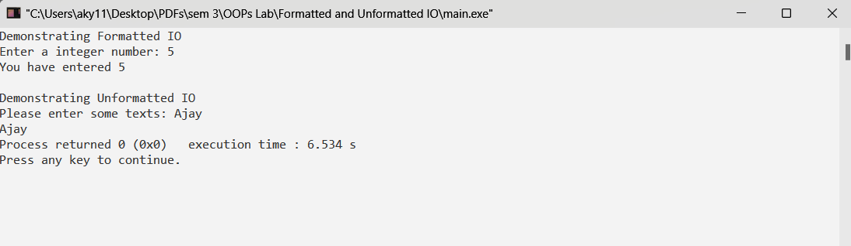

***Result***: Code executed successfully